Problem 3
In order to design a linear regression model using features that have a strong relation with number of tweets in the next hour, besides the features (i.e. number of tweets, total number of retweets, sum of the number of followers of the users posting the hashtag, maximum number of followers of the users posting the hashtag, and time of the day) we used in the problem 2, we extracted and explored the following features which are shown in the Table 3.1 in the problem 3.
Table 3.1 The features we explored in the problem 3
Features | Brief explanation of features
Acceleration | Sum of acceleration values of all tweets in 1-hour time windows
Favorite | Sum of all the favorite numbers of tweets in 1-hour time windows
Influential | Sum of the influence values of all tweets in 1-hour time windows
Matching | Sum of citation matching values of all tweets in 1-hour time windows
Momentum | Sum of momentum values of all tweets in 1-hour time windows
Ranking score | Sum of ranking values of all tweets in 1-hour time windows
Statuses | Sum of history statuses values of all users in the 1-hour time windows
Mentioned user | Number of users mentioned in all tweets in 1-hour time windows
User emotion | Number of repeated “!!!” and “???” in all tweets in 1-hour time windows

For the features we explored in the problem 3, some features can be easily obtained from the attributes of the tweets data, such as citation matching, ranking score, history statues, etc. Some other features, like number of users mentioned in the tweets and emotion of the tweets, require us to do some simple text analysis on the title part of the tweet. For number of users mentioned in the tweets, we extracted the tweet content (i.e. title) from the tweets data and then counted the number of symbol “@” in the content to calculate the feature values. Intuitively, when a user is mentioned by another user in the tweets, he or she is more likely to get involved with tweet interaction and is more likely to post a new tweet later. Therefore, we want to explore the relationship between number of users mentioned in the tweets and number of tweets in the next hour. As for the emotion of the tweets, we extracted the tweet content from the tweets data and then counted the number of repeated exclamation mark (!!!) and question mark (???). In the real world, Twitter users often use repeated letters or symbols to strengthen the mood. So, here we assumed that the repeated punctuation marks can indicate user’s emotion strength and considered repeated exclamation mark (!!!) and question mark (???) as special signals. What’s more, we thought that the more tweets that have strong emotion in 1-hour time window, the corresponding hashtag will be more popular.

In this problem, we extracted 14 features for each hashtag, i.e. #gohawks, #gopatriots, #nfl, #patriots, #sb49 and #superbowl. Before we trained linear regression models, we plotted number of tweets in 1-hour time windows versus each feature values, to intuitively check if there are strong correlations between number of tweets in 1-hour window and each feature values. Here, we take a look at the plots for hashtag #gohawks in the report. To check plots for other hashtag, you can find them in the corresponding folder in our final submitted file. Figure 3.1 shows the corresponding plots for hashtag #gohawks.
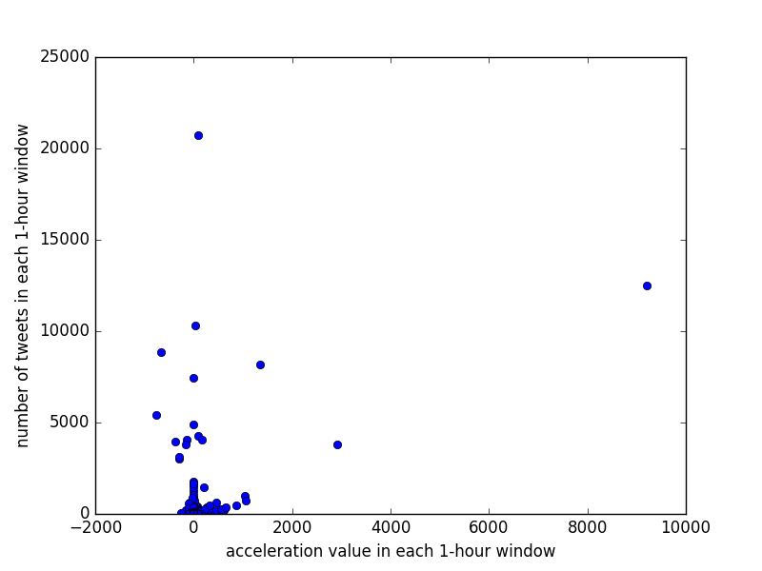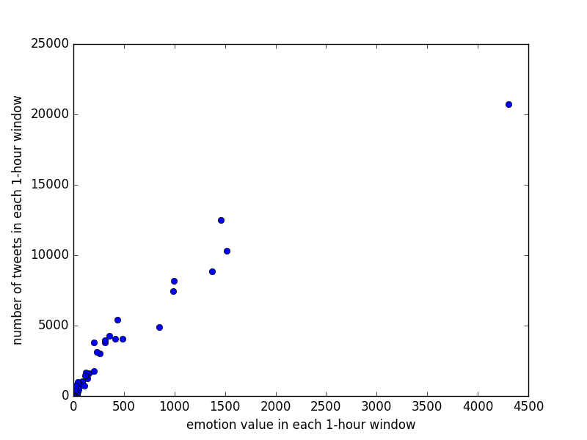
(a) (b)
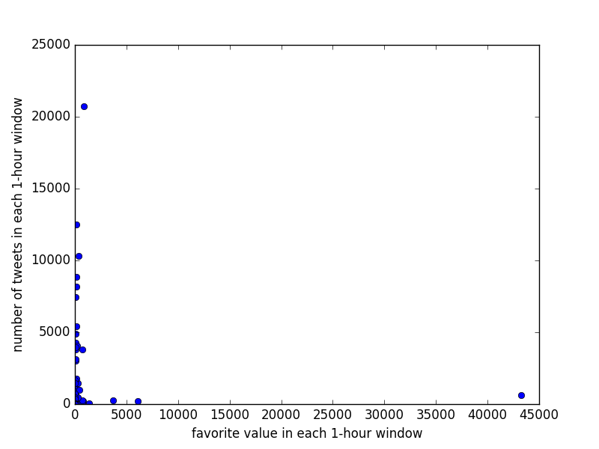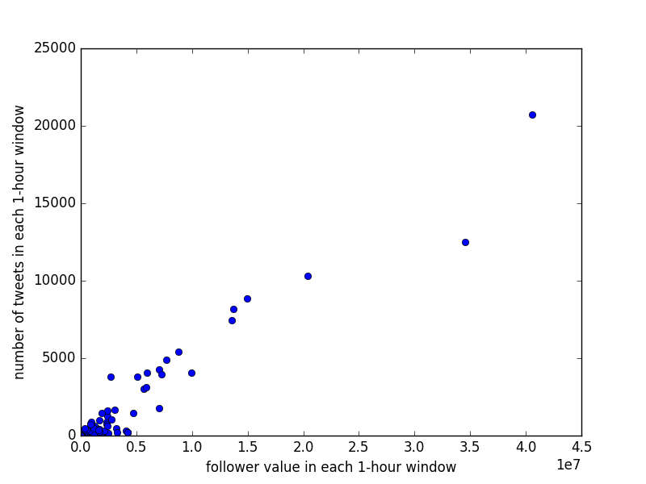
(c) (d)
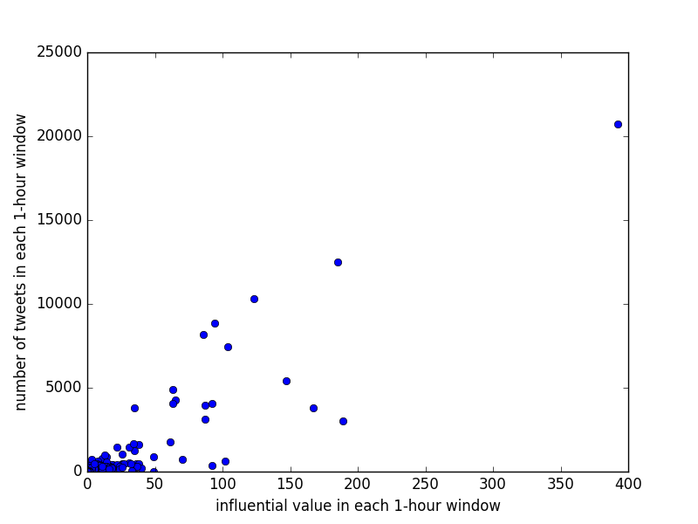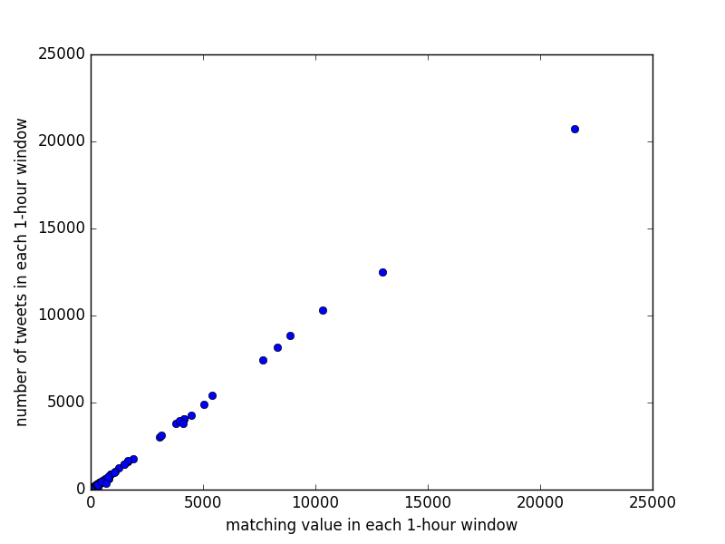
(e) (f)
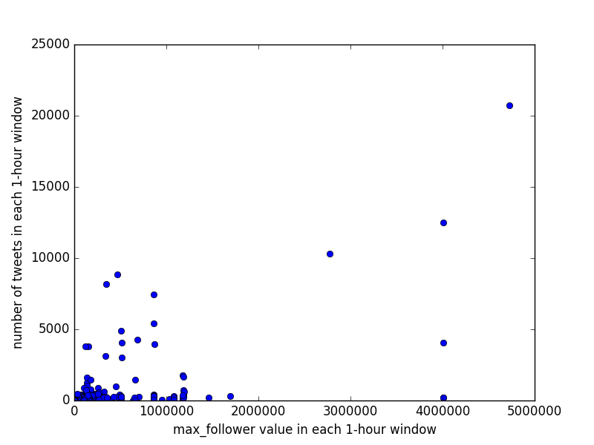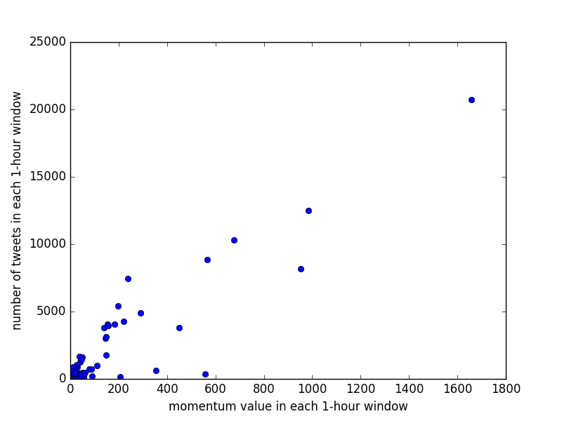
(g) (h)

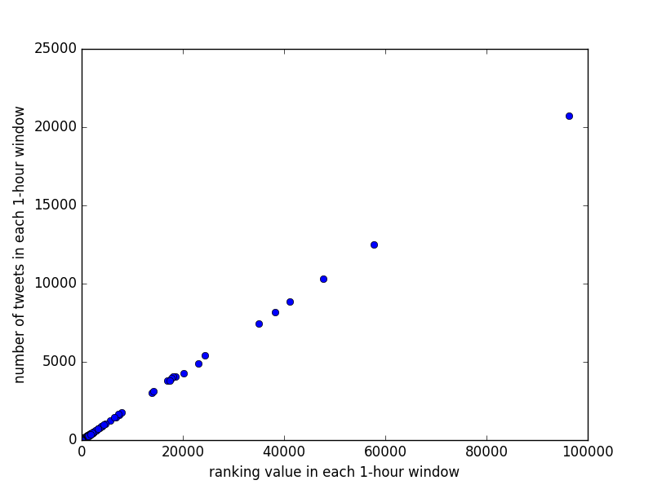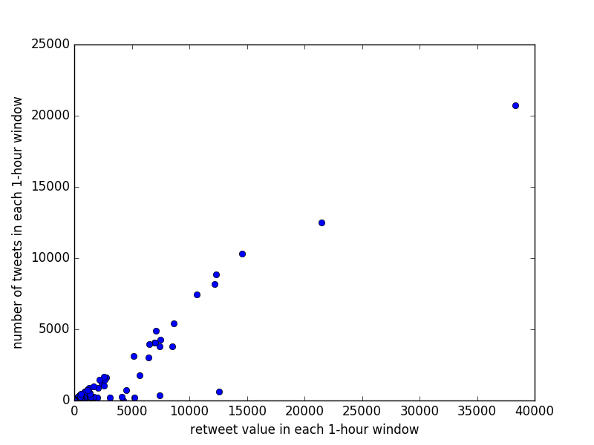
(i) (j)
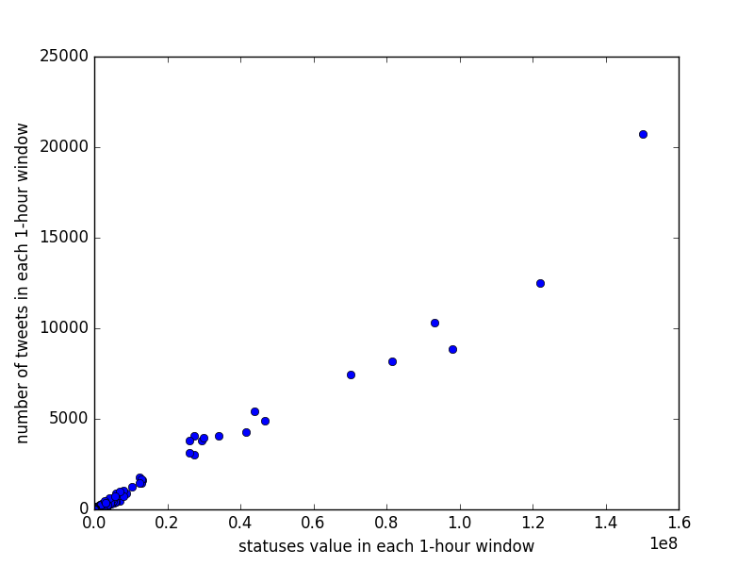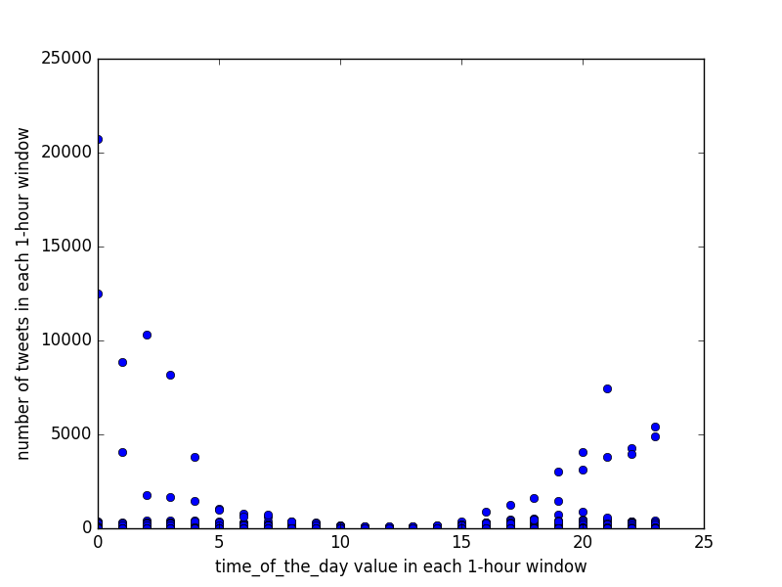
(k) (l)
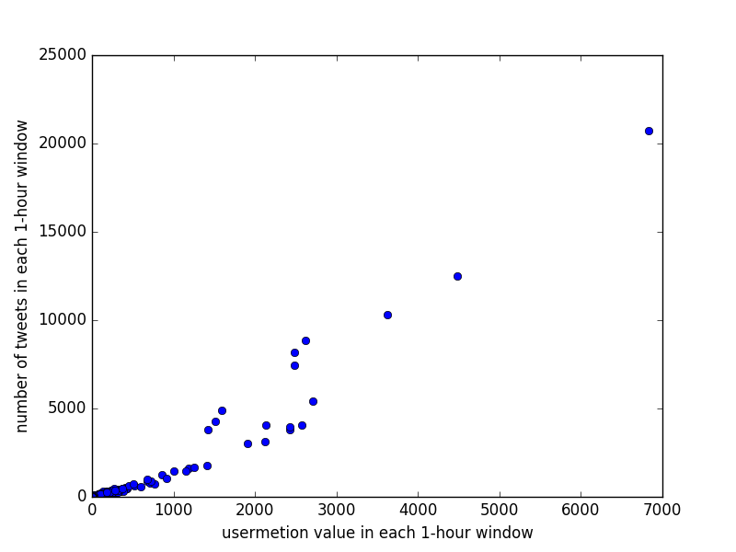
(m)
Figure 3.1 number of tweets in 1-hour time window versus each feature values: (a) acceleration, (b) user emotion, (c) favorite, (d) number of followers of the users (e) influential, (f) matching, (g) maximum number of followers of the users, (h) momentum, (i) ranking score, (j) number of retweets, (k) statuses, (l) time of the day, (m) number of users mentioned in the tweets.

From the plots in Figure 3.1, we found that there are some kinds of relations between number of tweets in the 1-hour time windows and several features, such as ranking score, number of retweets, number of the followers, number of users mentioned in the tweets, etc. However, some features don’t influence number of tweets in the 1-hour time windows significantly, like time of the day and maximum number of followers of the users. According to these observations, we could preliminarily select some useful features that we can use in the linear regression model and eliminate some useless features.

In the other hand, we directly used these 14 features to train a linear regression model for each hashtag and then checked the coefficient, t value, P value for each feature to select the useful features. In addition, we can also notice the R-squared value, which can be used to evaluate the performance of our linear regression models. Below is a ordinary least square regression results for hashtag #gohawks.

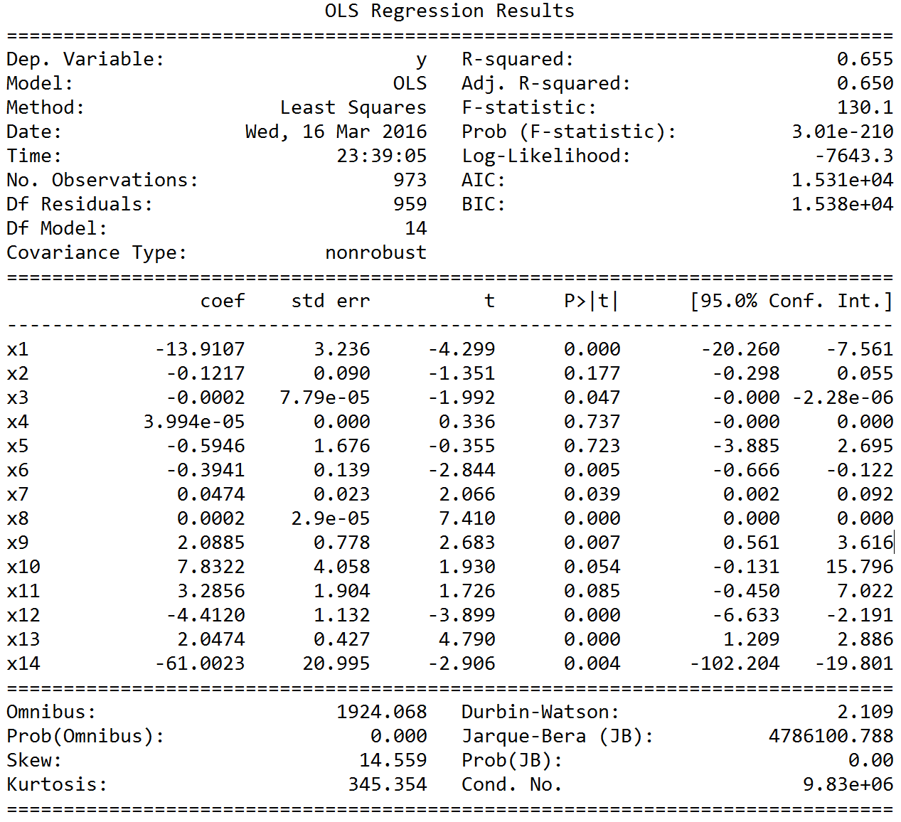

For a feature, when the coefficient is greater and standard error is smaller, there is a greater t-value, which means this feature is more useful. In addition, when the P-value is high, it means that there is not a strong correlation between the feature and number of tweets in the next hour.

After we intuitively checked the relation between number of tweets in the next hour and each feature as well as considered the significance of the feature (i.e. coefficient), t value and P value in our original linear regression model which used 14 features, we finally confirmed the useful features we want to use in our linear regression model. They are number of tweets, number of retweets, number of followers of the users, favorite, statuses, ranking score, number of users mentioned in the tweets.

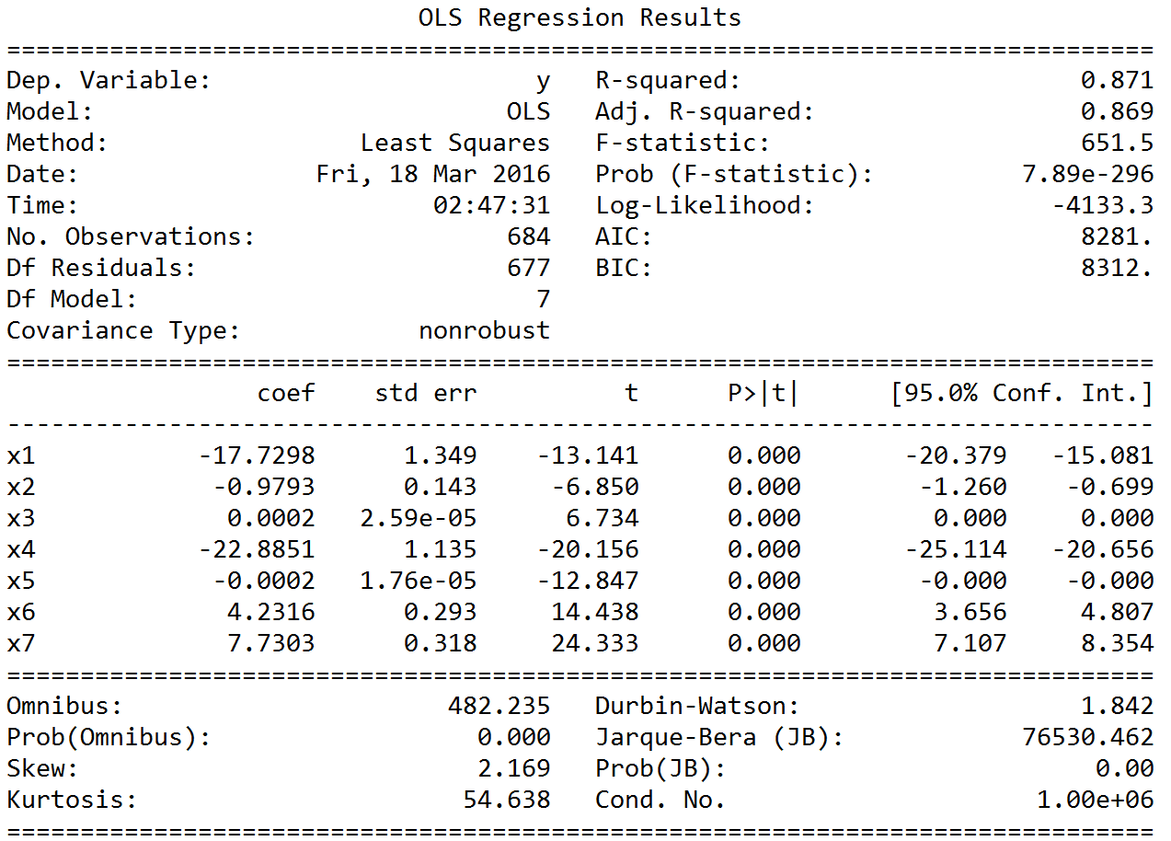

From this result, we can see that the P-value is all very low, and the coefficient is homogeneous. The 1stfeature No. of tweet and 4thfeature acceleration takes a significance role in the model. And also the feature of UserMention is really important. This result is quite reasonable, because the No. of tweets in previous hour is certainly the best feature to predict the No. of tweets in next hour, and the acceleration value is a coefficient that represent the tweet’s popularity. And the UserMention is also a latent factor that influence the future tweet number.

Then, we draw the scatter plot of predictant versus feature value for the top three features:
From the plots, we can easily see that most of the data point are scattered on a straight line. Some of the data points are extremely large, which is hard to predict because of lack of sufficient data to learn. So, these features show a nice performance overall.

